MONTREAL COGNITIVE ASSESSMENT (MoCA) VERSION 8.1 - ENGLISH


Date : Education : Age:
Installation :
YYYY-MM-DD
VISUOSPATIAL / EXECUTIVE |  |  |  |  |  |  |  |  | POINTS
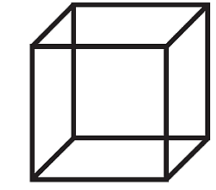  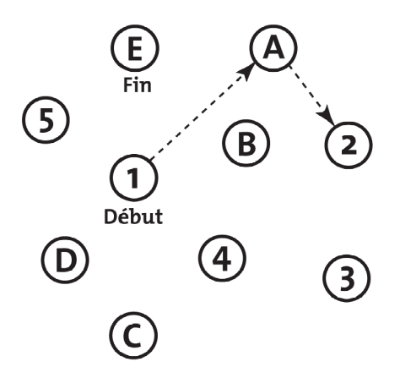  Copy cube  End  Begin  [ ] [ ] |  |  |  |  |  | Draw CLOCK (Ten past eleven)  (3 points)  [ ] [ ] [ ]  Contour Numbers Hands |  |  | ____  5
NAMING |  |  |  |  |  |  |  |  | ____  3
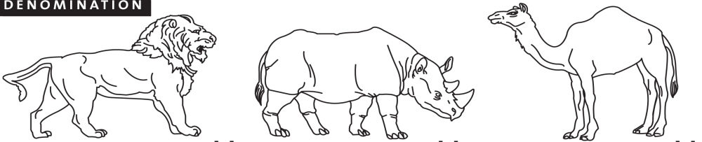  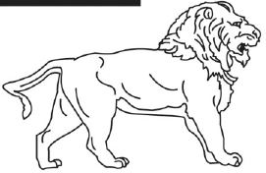  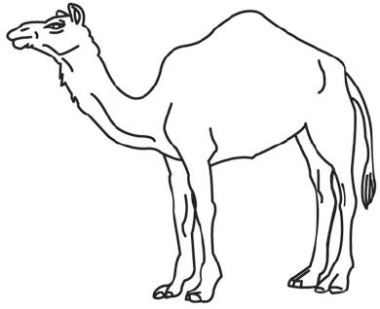  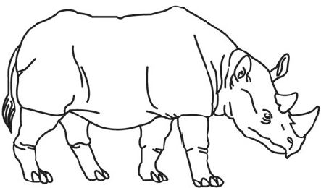  [ ] [ ] [ ] |  |  |  |  |  |  |  |  | ____  3
MEMORY | Read list of words, subject must repeat them. |  |  | FACE | VELVET | CHURCH | DAISY | RED | NO  POINT
Do 2 trials, even if 1st trial is successful. Do a recall after 5 minutes.
 |  |  | 1st trial |  |  |  |  |  | NO  POINT
 |  |  | 2nd trial |  |  |  |  |  | NO  POINT

ATTENTION |  |  | Read list of digits (1 digit/second). |  |  |  |  |  |  |  |  |  | _____2
Subject has to repeat them in the forward order [ ] 2 1 8 5 4  Subject has to repeat them in the backward order [ ] 7 4 2 |  |  |  |  |  |  |  |  |  |  |  |  | _____2
Read list of letters. The subject must tap with his hand at each letter A. No points if ≥ 2 errors  [ ] F B A C M N A A J K L B A F A K D E A A A J A M O F A A B |  |  |  |  |  |  |  |  |  |  |  |  | _____1
Serial 7 subtraction starting at 100. [ ] 93 [ ] 86 [ ] 79 [ ] 72 [ ] 65  4 or 5 correct subtractions : 3 pts; 2 or 3 correct : 2 pts; 1 correct : 1 pt; 0 correct: 0 pt |  |  |  |  |  |  |  |  |  |  |  |  | _____3
LANGUAGE |  | Repeat: I only know that John is the one to help today. [ ]  The cat always hid under the couch when dogs were in the room. [ ] |  |  |  |  |  |  |  |  |  |  | _____2
Fluency:  Name maximum number of words in one minute that begin with the letter F. [ ] ______ (N ≥ 11 words) |  |  |  |  |  |  |  |  |  |  |  |  | _____1
ABSTRACTION |  |  |  |  | Similarity between e.g. banana – orange = fruit  [ ] train – bicycle [ ] watch – ruler |  |  |  |  |  |  |  | _____2
DELAYED  RECALL |  | (MIS) |  |  | Has to recall words | FACE | VELVET | CHURCH | DAISY | RED |  | Points for UNCUED  recall  only | _____5
Memory  Index  Score  (MIS) |  | X3 |  |  | WITH NO CUE | [ ] | [ ] | [ ] | [ ] | [ ] |  | Points for UNCUED  recall  only | _____5
 |  | X2 |  |  | Category cue |  |  |  |  |  |  | MIS = ___/15 | _____5
 |  | X1 |  |  | Multiple choice cue |  |  |  |  |  |  | MIS = ___/15 | _____5
ORIENTATION |  |  |  | [ ] Date [ ] Month [ ] Year [ ] Day [ ] Place [ ] City |  |  |  |  |  |  |  |  | ____6
MIS: /15  (Normal ≥ 26/30)  Add 1 point if ≤ 12 years education |  |  |  |  |  |  |  |  |  |  | TOTAL ____/30
NOTES
© Z.Nasreddine MD www.mocatest.org Training and Certification is Mandatory

Name of Certified Professionnal : |  | Certification # :

Signature and profession : |  | Date :
 |  |  | YYYY-MM-DD

